
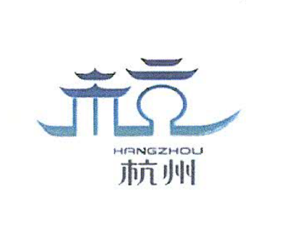
5 September, 2012
UNWTO/HTC
HIGH-LEVEL ASIA PACIFIC SYMPOSIUM ON MICE TOURISM
15-18 October 2012

Hangzhou, China

REGISTRATION FORM
Mr: □Mrs: □Ms:□
Participant Details
Country:
Surname:
First Name:
Organization/Company:
Position:
Full Address:
Telephone:
Fax:
Email (obligatory):
Event Participation Confirmation |  | YES | NO
Symposium
High-Level Asia Pacific Symposium on MICE Tourism (15th-18th October)
Welcome Dinner (15th October)
Working Lunch (16th October)
Farewell Lunch (17th October)
Technical Tours (international participants only)
Technical Tour (15th October, evening) Performance: Impression Westlake
Technical Tour (16th October, evening) Beijing and Hangzhou Grand Canal
Technical Tour (17th October, afternoon/evening) | Westlake cruise
Technical Tour (17th October, afternoon/evening) | Lingyin Buddha Temple
Technical Tour (17th October, afternoon/evening) | Performance: The Romance of Song Dynasty
Technical Tour (18th October, forenoon) | Xixi Wetland Park
Dietary Requirements

Arrival & Accommodation
Arrival date and time and flight number | Departure date and time and flight number
Date of check-in (day/month/year) | Date of check-out (day/month/year)

Contact Details
Ms. Lina Preuss  Regional Programme for Asia and the Pacific  World Tourism Organization  Capitan Haya 42  28020, Madrid, Spain  Tel: (+34 91) 567 9315  Fax: (+3491) 571 37 33  Email: asia@unwto.org | Mr. Roger Shu  M.I.C.E Department  Hangzhou Tourism Commission  Room 707, No.168, Mid. Zhonghe Rd.,  310002, Hangzhou, China  Tel: (+86 571)8720 4909  Fax: (+86 571)5681 5261  Email: roger@hz.cn

PLEASE REMEMBER TO ATTACH YOUR PASSPORT SCAN WHEN RETURNING THIS FORM.

